p

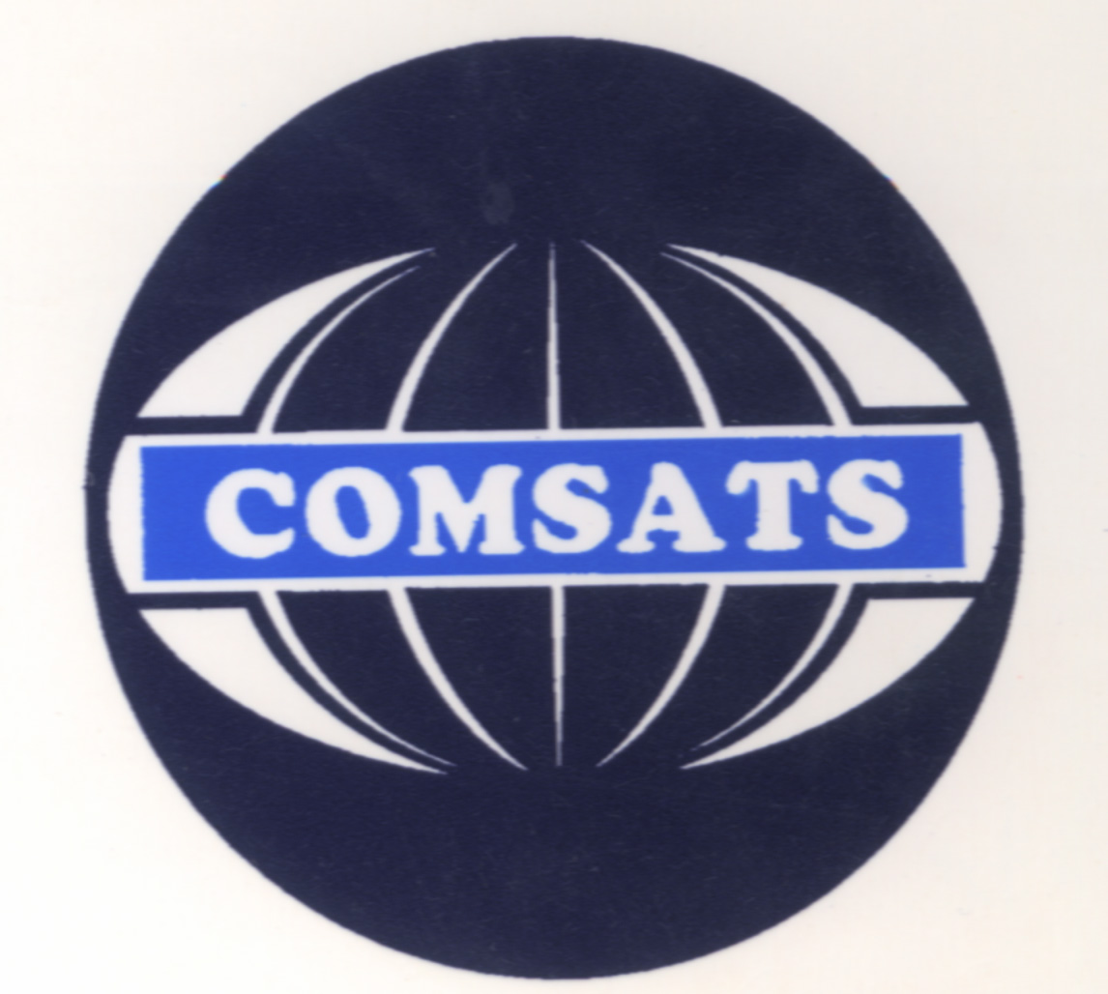
COMSATS University Islamabad,
Abbottabad campus

Course Plan

Semester Fall 2021

Introduction to Information and Communication Technologies (ICT)
Class: BS(SE)
First semester
Course Code: CSC 101
By: Malik Adnan Jaleel

Total Credit Hours: 3 | Lectures Credit Hours: 2 | Lab. Credit Hours: 1
Total Contact Hours: 6 | Lecture Contact Hours: 3 | Lab. Contact Hours:3

Office Hours (Day, time and place): Date and time will be communicated later

Pre-Requisite: Nil

Course Objectives and Outcomes

First Part Objectives | To provide basic understanding of information and communication technologies (ICTs). Discuss the four main functions of computer hardware: input, processing, output, and storage also Identify and describe major hardware components.
Second Part Objectives | After completion of the second part, the students will be able to understand basic concepts of computer programming. Which includes computer and computer Program, CPU level execution of program, overview of programming language, different levels of programming language, basic structure and elements of a C Program, input and output variables, data types, format specifiers, escape sequences, arithmetic operators, arithmetic assignment operators, precedence of operators, loops, conditional statements, switch etc.
Ultimate Objectives | Upon successful completion of a major in Introduction to ICT, students will be able to; Demonstrate proficiency in problem-solving techniques using the computer. Identify and describe major hardware components, basics of storage devices, number systems, machine cycle, microcomputer processor and use communications and networking terminology further include Internet operations and its uses. Students will be able to develop understanding of Computer programming is by its nature inherently mathematical. Learning a programming language is challenging and difficult and hard work for most students but upon completing this course the students should be able to understand the basic concepts related to programming.
Note: The contents may be revised, if deemed necessary after the first six weeks.

Course Outline and Contents
Week | Lecture | Topic Covered | Date / Time Delivered
Week-1 | Lecture#1 | Basic Definitions and Concepts of Computer
Week-1 | Lecture#2 | Introduction to The Parts of Computer Hardware
Week-2 | Lecture#3 | Computer Systems & Components
Week-2 | Lecture#4 | Storage Devices; primary storage devices, secondary storage devices, how data is stored
Week -3 | Lecture # 5 | Data Representation (Machine Level Representation of Data, Number Systems)
Week -3 | Lecture # 6 | Data Processing (Machine Cycle, and Microcomputer Processor)
Week -4 | Lecture # 7 | Software (Application Software and System Software)
Week -4 | Lecture # 8 | Operating Systems; Real time OS, Single User, Multi User, Single Tasking, Multitasking; Programming and Application Software
Week - 5 | Lecture # 9 | Computer Types (Single-user Computer, Multi-user Computer)
Week - 5 | Lecture # 10 | Networks; Uses, types of networks (LAN, WAN, Hybrid Networks), Structure of Network (Server based Network, Client Server Networks, Peer to Peer Networks)
Week - 6 | Lecture # 11 | Data Communication; Lines and Modems; Digital Data Connection, Broadband Connections, DSL Technologies
Week - 6 | Lecture # 12 | The Internet: Browsers and Search Engines, Email, Collaborative Computing and Social Networking
Week - 7 | Lecture # 13 | E-Commerce
Week - 7 | Lecture # 14 | Foundational Concepts in IT Security; Basic Security Concepts, Threats, Identify threats, Spam
Week - 8 | Lecture # 15 | Antivirus, Firewall, Intrusion Detection.
Week - 8 | Lecture # 16 | Introduction to Programming
Week - 9 | Lecture # 17 | Variable, Constants and Data types
Week - 9 | Lecture # 18 | Input/ Output Statements
Week - 10 | Lecture # 19 | Arithmetic Operators
Week - 10 | Lecture # 20 | Postfix, Prefix
Week - 11 | Lecture # 21 | Relational and Logical Operators
Week - 11 | Lecture # 22 | One-way selection using If condition, Two-way selection using If-else condition
Week - 12 | Lecture # 23 | If-else; if-else-if
Week - 12 | Lecture # 24 | Nested-if statement
Week -13 | Lecture # 25 | Switch Statement
Week -13 | Lecture # 26 | Nested Switch
Week - 14 | Lecture # 27 | While loop
Week - 14 | Lecture # 28 | do while loop
Week - 15 | Lecture # 29 | Nested loop
Week - 15 | Lecture # 30 | Nested loop
Week -16 | Lecture # 31 | Midterm
Week -16 | Lecture # 32 | Midterm

Recommended Books:
- Introduction to Computers, Peter, N., McGraw Hill, 2013.
- Using Information Technology: A Practical Introduction to Computer & Communications, Stacey, W.S & Sawyer, C., McGraw Hill, 2010.
- Turbo C Programming for the PC by Robert Lafore
- C How to Program by Dietel & Dietel (Latest Edition)

Recommended Compiler:
- Dev-C++

